**QUESTION 9**

**Submitted By: Anoushka Mergoju**

**This is the code that I have compared for CPU and GPU to answer Question 9.  
The code fragment has been taken from:**

**Quiz 8 – Question 8**

**CPU Server Code:**

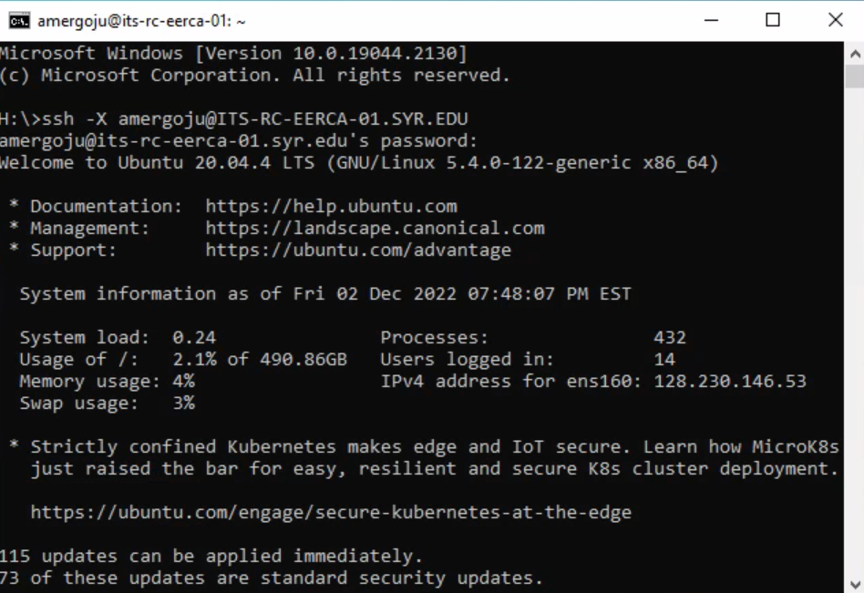

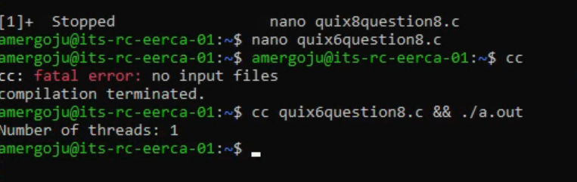

This is the code fragment from Quiz 8, Question 8. I mistakenly mentioned as Quix6Question8 but it I from quiz 8.

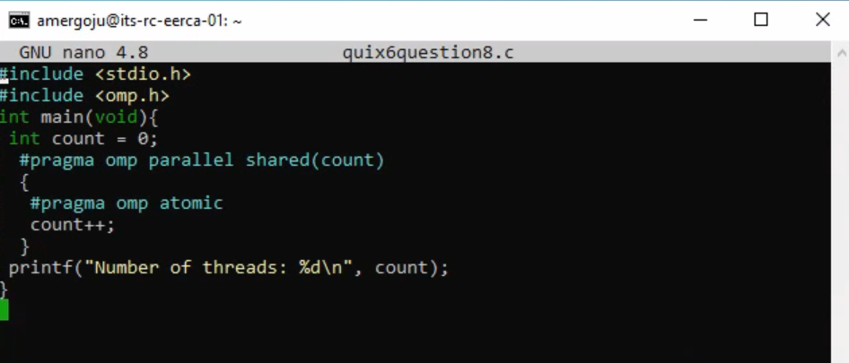

**GPU Server Code:**

